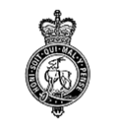 | BUDBROOKE PARISH COUNCIL  Clerk: Kay Sheriston  21 Hampton Croft, Hampton on the Hill, WARWICK, Warks CV35 8BJ  07708 177206 / email: clerk@budbrookepc.org.uk  Website: www.budbrookepc.org.uk
To all members of the Council
You are hereby summoned to attend an ordinary meeting of Budbrooke Parish Council to be held at Budbrooke Community Centre on Wednesday 7th December 2022, for the purpose of transacting the following business.

A G E N D A

1. Public Participation
2. Register, Apologies & Declarations of Interest & Dispensations
3. Approve previous minutes
4. Matters Arising.
5. CIL Projects – Update
6. Benches
7. Recruitment of 2 x Councillors
8. BPC Planning working document / CIL Funds proposals – update
9. Coronation of King Charles III - Saturday 6th May
10. Planning
11. Correspondence
12. Parish Maintenance/Playgrounds
13. Community Centre/Village Hall Items
14. Newsletter/Website/Facebook
15. Finance
16. Any Other Business
17. Next meeting arrangements
The next meeting will be held on Wednesday 4th January 2023 at 8pm in the Community Centre.
18. Private Session (if required)

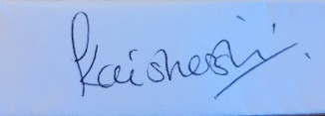

Kay Sheriston
Clerk & RFO – Budbrooke Parish Council
29th November 2022

