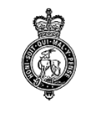 | BUDBROOKE PARISH COUNCIL  Clerk: Kay Sheriston  21 Hampton Croft, Hampton on the Hill, WARWICK, Warks CV35 8BJ  07708 177206 / email: clerk@budbrookepc.org.uk  Website: www.budbrookepc.org.uk

To all members of the Council
You are hereby summoned to attend an ordinary meeting of Budbrooke Parish Council to be held at Budbrooke Community Centre on Wednesday 4th January 2023 for the purpose of transacting the following business.

A G E N D A

1. Public Participation
2. Register, Apologies & Declarations of Interest & Dispensations
3. Approve previous minutes
4. Matters Arising.
5. South Warwickshire Local Plan – Consultation Jan/Feb
6. CIL Projects – Update
7. Benches
8. Recruitment of 2 x Councillors - update
9. Planning
10. Correspondence
11. Parish Maintenance/Playgrounds
12. Community Centre/Village Hall Items
13. Newsletter/Website/Facebook
14. Finance
15. Any Other Business
16. Next meeting arrangements
The next meeting will be held on Wednesday 1st February 2023 at 8pm in the Community Centre.
17. Private Session (if required)

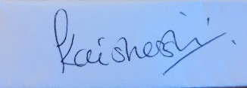

Kay Sheriston
Clerk to the Council
27th December 2022

