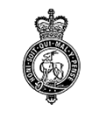 | BUDBROOKE PARISH COUNCIL  Clerk: Kay Sheriston  21 Hampton Croft, Hampton on the Hill, WARWICK, Warks CV35 8BJ  07708 177206 / email: clerk@budbrookepc.org.uk  Website: www.budbrookepc.org.uk
To all members of the Council
You are hereby summoned to attend an ordinary meeting of Budbrooke Parish Council to be held at Budbrooke Community Centre on Wednesday 1st June at 8pm, for the purpose of transacting the following business.

A G E N D A

1. Public Participation.

2. Register, Apologies & Declarations of Interest & Dispensations.

3. Approve May meeting minutes (AM and APM).

4. Matters Arising.

5. BPC Planning working document / CIL Funds proposals.

6. Planning

7. Correspondence

8. Parish Maintenance/Playgrounds

9. Community Centre/Village Hall Items

10. Finance

11. Newsletter/Website/Facebook

12. Any Other Business

13. Next meeting arrangements
The next meeting will be held on Wednesday 6TH July at 8.00 pm in the HM Magna Community Centre.

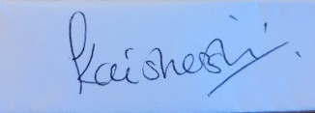

Kay Sheriston
Clerk to the Council
25th May 2022

