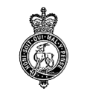 | BUDBROOKE PARISH COUNCIL  Clerk: Mrs Simone Bush  17 Hicks Close, Warwick, CV34 5ND  07708 177206 / email: clerk@budbrookepc.org.uk  Website: www.budbrookepc.org.uk
____________________________________________________________________________

BUDBROOKE PARISH COUNCIL MEETING
Notice is hereby given that an ordinary meeting of Budbrooke Parish Council will be held at Budbrooke Community Centre on Wednesday 1st August 2018 at 8pm, for the purpose of transacting the following business.
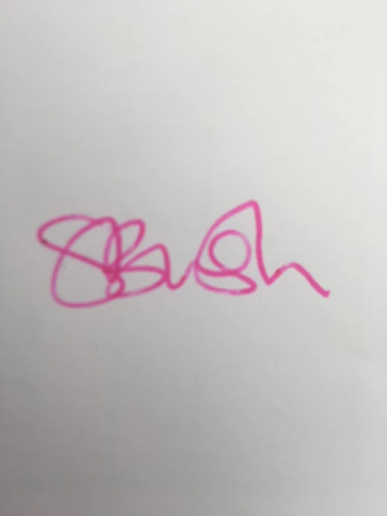
Simone Bush
Clerk to the Council
26/7/18
AGENDA
1 | PUBLIC COMMENTS
2 | DECLARATIONS OF INTEREST & DISPENSATIONS
3 | APOLOGIES & ACCEPTANCE OF REASONS FOR ABSENCE
4 | MINUTES OF PREVIOUS MEETING
5 | POLICE MATTERS / WRW COMMUNITY FORUM ISSUES
6 | PLAYGROUNDS
7 | MATTERS ARISING
8 | CORRESPONDENCE
9 | PARISH MAINTENANCE
10 | MATTERS PERTAINING TO OUTSIDE BODIES (CC/VH/OTHER)
11  12 | PLANNING MATTERS  REVIEW OF COMPLAINTS PROCEDURE
13 | NEWSLETTER & WEBSITE
14 | FINANCIAL INFORMATION
15 | MATTERS FOR INCLUSION ON NEXT AGENDA
16 | DATE OF NEXT MEETING

